NEPAL COLLEGE OF INFORMATION TECHNOLOGY
B. E. Computer Engineering, Semester – 8
Semester End Assessment, 2008

Subject: CMP 421.3 - Artificial Intelligence | Full Marks: 100
Time: 3 hours | Pass Marks: 50

Candidates are required to write their answer in their own words as far as practicable.

Attempt ALL questions.

Q. 1. | What is a semantic net? How knowledge is inferred in semantic net? What is the difference between ‘isa’ and ‘instance’ relationship? (2+5+3)
Q. 2. | Demonstrate convergence property of a perceptron with suitable example. Write short note on Multi-Layered Perceptron. (5+5)
Q. 3. | Explain working of STRIPS with suitable example. (10)
Q. 4. | Complete following tree using standard notations used for min-max tree. Determine the nodes to be pruned using alpha-beta pruning algorithm. (10)  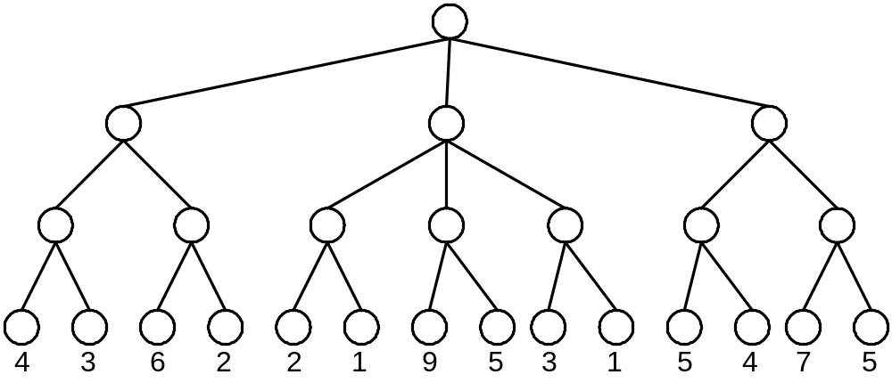  OR  Explain hill climbing local search algorithm. What are the problems associated with hill-climbing local search algorithm? Explain the solutions. (3+4+3)
Q. 5. | Use the following example, convert the sentences into FOL, then into CNF, and apply resolution algorithm to find the answer to the query. (3+3+4)  Premises: Happy student – Anyone passing his history exams and winning the lottery is happy. But anyone who studies or a lucky can pass all his exams. John did not study but he is lucky. Anyone who is lucky wins the lottery.  Query: Is John happy?
Q.6. | i) Write Prolog source code to support following sentence using operators. (5)  The wise king made good decision.  ii) Explain the destructive modification operations on lists in Lisp. (5)
Q.7. | Explain A* search algorithm with a suitable example. Write short notes on variants of A*.  (6+4)
Q.8. | Explain the steps in communication? How Natural Language Understanding architecture is used to understand the meaning of given paragraph? (5+5)
Q.9. | Explain the Baye’s rules. How Baye’s rules are used for combined evidence, explain with suitable example. (4+6)
Q.10. | Write short notes on any two. (5+5)  - XOR problem  - Backward chaining  - Logical equivalences
 Good Luck @ Assessment 

